Date | January 2017 Music Lesson Plans  Bonnie Kimbrough, MicroSociety |  | Frameworks
1st Grade | The percussion family will be explored. Students will have hands on basic instruments.  Beach ball activities:  - Steady beat  - Beat one of each musical measure  - Change routine as the phrases change  Bucket Drum |  | M.1.1.1  M1.1.2  M.1.1.3  M.3.1.3
2nd Grade | The percussion family will be explored. Students will have hands on basic instruments.  Beach ball activities:  - Steady beat  - Beat one of each musical measure  - Change routine as the phrases change  Bucket Drum  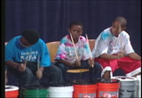 |  | M.1.2.1  M.1.2.2  M.1.2.3  M.1.2.5  M.2.2.3  M.3.2.3
3rd Grade | 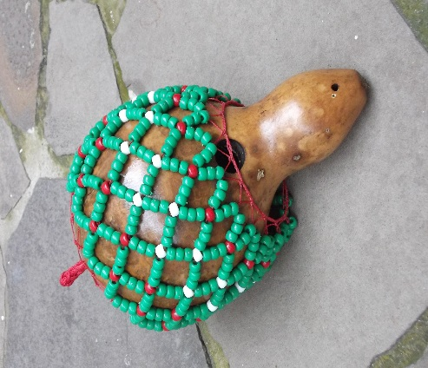  The students will begin making shekeres out of gourds. |  | M.1.3.1  M.1.3.2  M.1.3.3  M.2.3.3  M.3.3.3
4th Grade | The students will begin the study of Hawaii and learning a Musical Program for presentation. |  | M.1.4.8  M.2.4.2  M.4.4.1  M.4.4.2
5th Grade | The students will begin learning a “Surfing” school program.  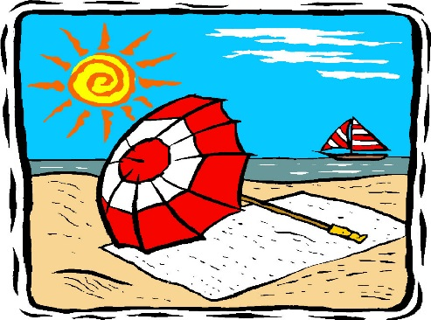 |  | M.1.5.2  M.1.5.3  M.2.5.1M  M.4.5.1  M.4.5.3
©HaveFunTeaching.com
Date
6th Grade | The percussion family will be explored. Students will have hands on basic instruments.  Beach ball activities:  - Steady beat  - Beat one of each musical measure  - Change routine as the phrases change  - Create routines in small groups for demonstration.  Bucket Drum  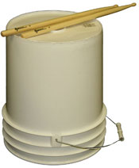 |  | M1.6.2  M.1.7.3  M.1.6.7  M.3.6.3M.2.6.4
Kindergarten | Drumming!  Boomwhackers  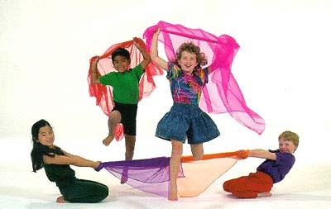  Scarves |  | M.1.k.1  M.1.k.3  M.2.k.2  M.2.k.3  M.3.k.3  M.4.k.1
unTeaching.com

